

ProjectInitializationandPlanningPhase

Date | 19February2026
TeamID | LTVIP2026TMIDS66458
ProjectName | GeminiHistoricalArtifact Description
MaximumMarks | 3 Marks
DefineProblemStatements(CustomerProblemStatement Template):
Understanding historical artifacts requires extensive research, expert knowledge, and access to reliable historical sources. Many historians, students, museum curators, and content creators spend significant time gathering information and crafting detailed descriptions of artifacts. This process can be time- consuming and may limit the accessibility of historical knowledge to a wider audience.Additionally, generating engaging and informative content that accurately reflects the historical significance, cultural context, and material details of artifacts is challenging without specialized expertise.To address these challenges,thereisaneedforanintelligentsystemthatcanautomaticallygeneratehigh-qualityhistorical descriptions while reducing manual effort.The problem is to develop a web-based application that leverages Generative AI to produce detailed, accurate, and engaging descriptions of historical artifacts basedonuserinputsuchasartifactnameorhistoricalperiod.Thesystemshouldenhanceproductivityfor researchers and educators while making historical information more accessible to everyone.

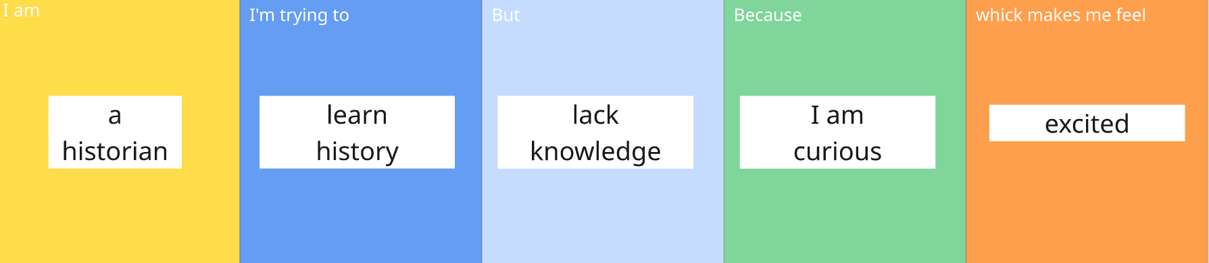

Problem Statement(PS) | I am (Customer) | I’mtryingto | But | Because | Whichmakesme feel
PS-1 | a historian | learnhistoryto better understand historical artifacts | lack knowledge | Iamcurious | excited

